# CS 255 System Design Document Template

This template lays out all the different sections that you need to complete for Project Two. Each section has guidance to prompt your thinking. You will need to continually reference the interview transcript as you work to make sure that you are addressing your client’s needs. There is no required length for the final document. Instead the goal is to complete each section based on what your client’s needs are. Remove this note when you are finished, and replace all bracketed text with the relevant information.

## UML Diagrams

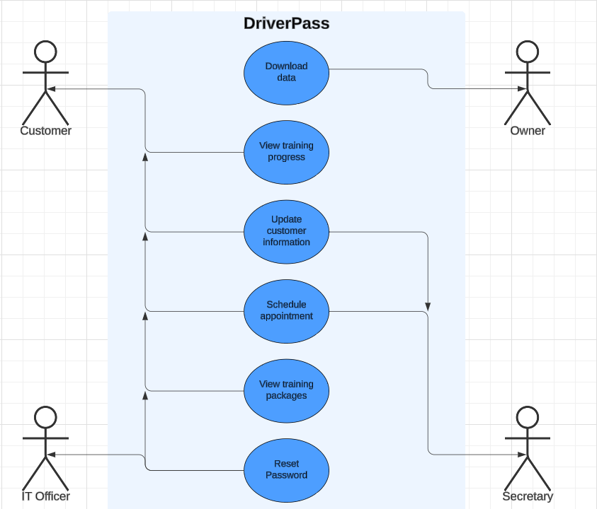

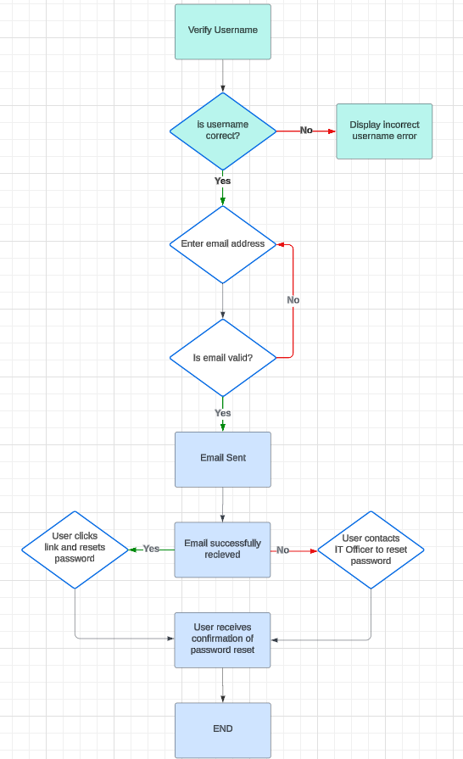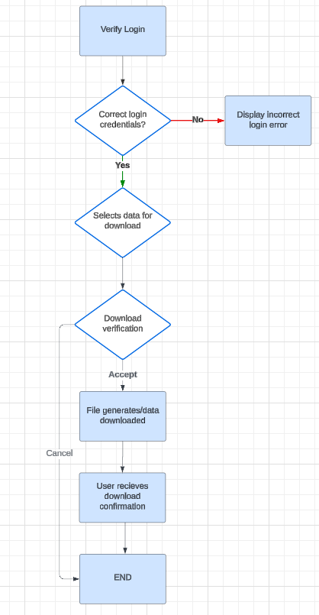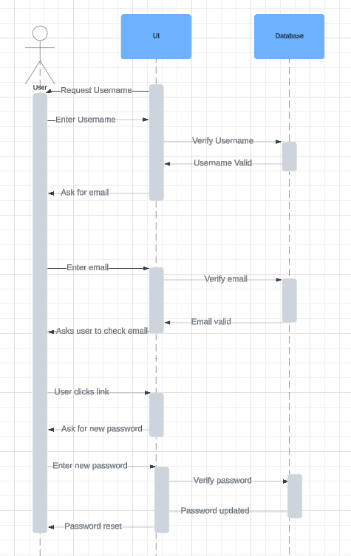

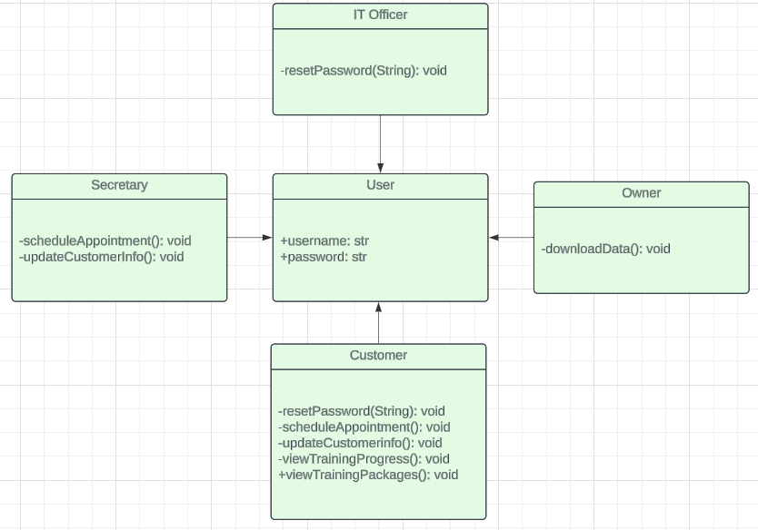

## Technical Requirements

Our system here has several technical requirements. We need to create a web-based system complemented by a mobile version so the owner can access downloaded data on the go. A database will be necessary to store login credentials and essential information, whether it's cloud-based or hosted in a physical data center. All data exchanges between a user and the system and internal data sharing must be encrypted with SSL to maintain data integrity and security. Using a cloud platform will facilitate quicker updates, such as for scheduling appointments via the training calendar or tracking a user's progress. Role-based access controls will also be essential; for example, the owner will have privileges that a customer does not, the IT officer will have capabilities that the secretary does not, and so on.